

Design Document for:

Stupid Robot

Dr. Robot (or how I learned to stop worrying and love AI)

Training AI programmers, one entity at a time.

“You WILL be assimilated”™

All work Copyright ©2009 by SeeaütS

Written by David Moss, Tom Lindeman, Corwin VanHook, Oscar Maldonado, Amber Clarke, Crhis, Giovanni

Version # 1.00

Projekt1 1
Dr. Robot (or how I learned to stop worrying and love AI) 1
Design History 5
Version 1.0 January 13, 2009 5
Version 1.01 January 14, 2009 5
Version 1.02 January 15, 2009 5
Game Overview 6
Philosophy 6
Philosophical point #1 6
Philosophical point #2 6
Philosophical point #3 6
Common Questions 6
What is the game? 6
Why create this game? 6
Where does the game take place? 6
What do I control? 6
What is the main focus? 6
What’s different? 6
Feature Set 7
General Features 7
Multiplayer Features 7
Editor 7
Gameplay 7
The Game World 8
Overview 8
World Feature #1 8
World Feature #2 8
The Physical World 8
Overview 8
Travel 8
Scale 8
Objects 8
Rendering System 8
Overview 8
2D/3D Rendering 8
Camera 9
Overview 9
Camera Detail 9
Game Engine 9
Overview 9
Game Engine Detail #1 9
Water 9
Collision Detection 9
Lighting Models 9
Overview 9
Lighting Model Detail #1 9
Lighting Model Detail #2 9
Levels 10
Overview 10
Level 0 - Tutorial 10
Level 1 10
Level 2 10
Level 3 10
Level 4 10
Level 5 10
Level 6 10
Level 7 10
Level 8 10
Level 9 10
Level 10 10
Level 11 10
Level 12 10
Level 13 10
Level 14 10
Level 15 10
Game Characters 11
Overview 11
Creating a Character 11
Robot Commands and Information 11
Enemies, Obstacles, Objects, Floor Types, etc. 13
User Interface 14
Overview 14
User Interface Detail #1 14
User Interface Detail #2 14
Overview 15
Audio Format 15
3D Sound 15
Sound Design 15
Single-Player Game 16
Overview 16
Single Player Game Detail #1 16
Single Player Game Detail #2 16
Story 16
Hours of Gameplay 16
Victory Conditions 17
Character Rendering 18
Overview 18
Character Rendering Detail #1 18
Character Rendering Detail #2 18
World Editing 19
Overview 19
World Editing Detail #1 19
World Editing Detail #2 19
Extra Miscellaneous Stuff 20
Overview 20
Junk I am working on… 20
“XYZ Appendix” 21
“Objects Appendix” 21
“User Interface Appendix” 24
“Networking Appendix” 24
“Character Rendering and Animation Appendix” 24
“Story Appendix” 25

Design History

This is a brief explanation of the history of this document.

In this paragraph describe to the reader what you are trying to achieve with the design history. It is possible that they don’t know what this is for and you need to explain it to them.

Version 1.0 January 13, 2009

Initial version, includes everything from the high concept document

- Transferred over content from high concept document
- Initial versions of the following filled out
  - Common questions
  - Feature set
  - Game World
  - Game Characters
    - Robot Commands
    - Programmable Commands
    - Advanced Commands
    - Subroutines
    - Initial Object/Floor Tile Listing
    - Music/Sound

Version 1.01 January 14, 2009

Added in additional floor tile types.

Version 1.02 January 15, 2009

Fleshed out basic floor tile types as well as generation a legend for map creation.
Added in object appendix for floor tiles.
Added preliminary tutorial levels.

Game Overview

Philosophy

Philosophical point #1

This game will allow players to program an AI entity much in the way that a Lego Mindstorm project is programmed, centered around problem solving.

Philosophical point #2

Philosophical point #3

Common Questions

What is the game?

Teach artificial entities to solve puzzles in order to navigate their world. Using logic blocks you will become a programmer and work through the devious challenges that await.

Why create this game?

This game is designed to be a project of a reasonable scope that can be completed for the purposes of our Senior Project.

Where does the game take place?

The game takes place in an ultra secret laboratory.

What do I control?

You will control the command logic blocks that get placed into a robot’s memory. The robot will then perform the commands that are in memory.

What is the main focus?

Throughout the ultra secret laboratory are many obstacles that must be overcome. By programming the robot with various instructions, the robot will be able to complete the various levels and progress through additional levels.

What’s different?

The player will be in control of an AI’s logic programming, which will allow players to see what effect different commands give and introduce people to a very simplistic form of programming.

Feature Set

General Features

15 Levels
X Commands
Y Robot Types
OpenGL Support

*3D graphics
*5.1 Surround Sound
*Runs on PC, Linux, Macintosh, Xbox 360
*Hundreds of achievements available to the player!

Multiplayer Features

*World Wide High Score tracking

Editor

*Create and design your own levels
*Share custom built levels with the world
*Get levels from internet

Gameplay

Program a robot’s AI in order to get it through various challenges.
Try to figure out the most efficient programming possible, fewer commands equals higher score!
Try as many times as you like, until you complete a challenge.
Attempt three different difficulty levels of game play.

The Game World

Overview

You will view the game world from a ¾ isometric view. The game world will be tile based and allow panning around to view portions of the game world.

World Feature #1

This section is not supposed to be called world feature #1 but is supposed to be titled with some major thing about the world. This is where you break down what is so great about the game world into component pieces and describe each one.

World Feature #2

Same thing here. Don’t sell too hard. These features should be awesome and be selling the game on its own.

The Physical World

Overview

Describe an overview of the physical world. Then start talking about the components of the physical world below in each paragraph.

Travel

The player moves the robot through the world by programming AI commands into the robot’s memory.

Scale

The world scale will be….

Objects

Objects will be obstacles in the way, preventing the robot from completing a level.

See the “Objects Appendix” for a list of all the objects found in the world.

Rendering System

Overview

The game will be rendered using our custom built 2D DirectX Engine.
*The game will be rendered using our custom built 3D DirectX Engine
*The game will be rendered using our custom built 3D XNA Engine

2D/3D Rendering

2D DirectX –
*3D DirectX –
*3D XNA –

Camera

Overview

The camera will be positioned up in the air, pointing down at an angle toward the ground.

Camera Detail

The camera will pan around the world, allowing the player to view what obstacles may be in the way.

Game Engine

Overview

Describe the game engine in general.

Game Engine Detail #1

The game engine will keep track of everything in the world like such and such.

Water

There will be water in the world that looks awesome and our game engine will handle it beautifully.

Collision Detection

Our game engine handles collision detection really well. It uses the such and such technique and will be quite excellent. Can you see I am having a hard time making up stupid placeholder text here?

Lighting Models

Overview

Describe the lighting model you are going to use and then go into the different aspects of it below.

Lighting Model Detail #1

We are using the xyz technique to light our world.

Lighting Model Detail #2

We won’t be lighting the eggplants in the game because they are purple.

Levels

Overview

Provide an overview here.

Level 0 – Tutorial

Level Number | Title | Map | Completion Method
0.1 | Moving and Activating | 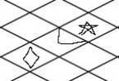 | move forward  activate  move forward
0.2 | Moving and turning | 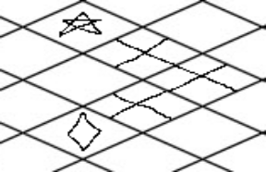 | move forward 2 squares  turn left  move forward 2 squares
0.3 | Moving until you hit an obstacle | 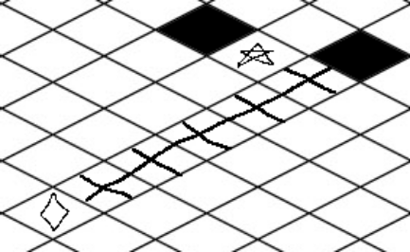 | move forward until you hit an obstacle  turn left  move forward until you hit an obstacle
0.4 | Crouching | 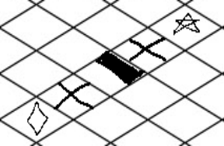 | move forward  crouch  move forward
0.5 | Jumping | 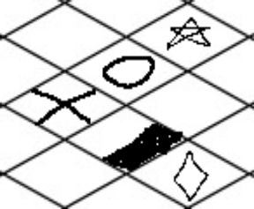 | jump  turn right  jump
0.6 | Punching | 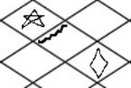 | move forward  punch  move forward
0.7 | Full Tutorial Level | 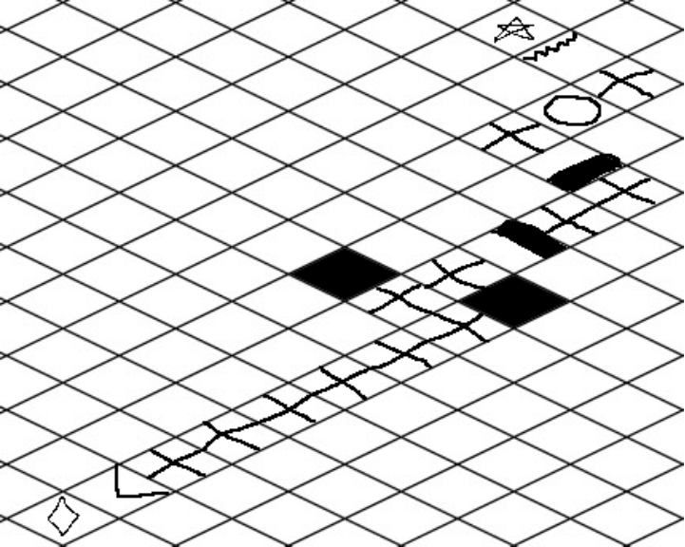 | Move forward  activate  move forward until you hit a wall  turn left  move forward  turn right  move forward  move forward  crouch  move forward  move forward  turn left  jump  turn right  jump  turn left  move forward  punch  move forward

Level 1

Level 2

Level 3

Level 4

Level 5

Level 6

Level 7

Level 8

Level 9

Level 10

Level 11

Level 12

Level 13

Level 14

Level 15

Game Characters

Overview

Over of what your characters are.

Creating a Character

Handled inside the ProfileManagement gamestate.

Robot Commands and Information
Memory Blocks
Each level will give the robot a memory block of X commands.
Each command will take up a specified space in memory, depending on what the command is.
The memory block will process commands until it reaches the bottom of the command list, then it will repeat back to the top.

Basic Robot Commands (part of the robot class)

- Move Forward
  - Moves the robot forward one square

- Turn Left
  - Turns the robot left 90 degrees

- Turn Right
  - Turns the robot right 90 degrees

- Crouch
  - Makes the robot crouch down.
  - The robot can move while crouched, but cannot turn, climb, jump or punch.

- Climb
  - Makes the robot attempt to climb over or on top of whatever obstacle is in front of it.

- Jump
  - Makes the robot jump forward based upon its jump distance. Default jump distance is far enough to clear a single square.

- Punch
  - Makes the robot punch the square in front of itself.

- Activate Object
  - Attempt to activate whatever is in front of the robot.

- Wait for X ticks
  - Robot pauses in his position for x ticks

Programmable Commands
Programmable commands consist of Basic Robot Commands and are what are available to the user. Some are direct duplicates of the basic commands, some are not. Each command takes up a pre-defined amount of memory in the robot’s memory block

- Move Forward 5 bytes
- Move Forward X Squares 7 bytes
- Move Forward until you hit an obstacle 10 bytes
- Turn Left 3 bytes
- Turn Right 3 bytes
- Crouch 4 bytes
- Jump 15 bytes
- Punch 6 bytes
- Loop (default last command in memory blocks) 0 bytes
- Activate 15 bytes

Sample memory block for navigating a simple maze
Move Forward until you hit an obstacle
Turn Left
Loop

Advanced Commands
Advanced commands allow some level of user controlled looping within the programmable commands.
- Repeat-Until 10 bytes
  - Repeat will be inserted into the memory block
  - Until will be required to be inserted at some point after the repeat is inserted
  - Until will have several versions available.
    - Until there is a X in front of the robot.
    - Until there is a X to the right of the robot.
    - Until there is a X to the left of the robot.
      - Where X can be any object available, i.e. “wall”, “moveable square”
, “gap in the ground”, etc.

Sub Routines
Sub routines are pre-programmed blocks of code that take up less space than if the commands were input directly. However, these sub routines may not always be of use for that particular level. Sometimes they will be made available strictly as red herrings.

For example:
- Move forward 2 squares then turn left 9 bytes
- Move forward 2 squares then turn right 9 bytes
- Move forward until you hit an obstacle then turn left 12 bytes
- Move forward until you hit an obstacle then turn right 12 bytes
- Repeat “Jump” Until there is a wall in front of the robot. 23 bytes

Enemies, Obstacles, Objects, Floor Types, etc.

- See Object Appendix

User Interface

Overview

The game interface will be designed in such a way that all navigation is very simplistic, primarily consisting of basic keyboard inputs, such as up, down, left, right, “accept” and “back”.

User Interface Detail #1
All interfaces will be clear and obvious what you are about to do. If the interface is even remotely ambiguous, additional information will be provided to the user.

User Interface Detail #2
The game board will show the robot’s progression through the level. Additionally the game board will show the memory block on the right side of the screen, as well as the current command being processed.
Musical Scores and Sound Effects

Overview

* The overall music will have a somewhat robotic theme that varies depending on the level you are on. Music will vary from slow and calm to fast and hectic

Audio Format

This being a student project and not for sale, we will probably be using MP3 audio when possible. Otherwise we will be using .wav format in all likelihood.

3D Sound

DirectSound APIs will be used.

Sound Design

Clear and obvious sounds will be used in order to portray what is going on in the game, in addition to visual representations of what is occurring.

Single-Player Game

Overview

The player can load a profile which saves player progress through levels. From there they can choose a level to play. If the player does not wish to create a profile they can use quick-play to select a level to play from. If they choose this option, they will not be able to save their high scores.
The player creates a profile (or doesn’t) and starts the first puzzle. A puzzle starts with a “Level View” where they can move the camera around the world to try and understand the challenge. In Level View, there will be clearly defined Start and Goal tiles which can be represented by Red and Green circles respectively.
The player then has the option to open the “Logic View” which is where most of the game’s interaction takes place. This has all of the available logic blocks and slots to place them. They can activate routines from this menu, starting the AI’s actions.
In the “Logic View” screen, the player has a bank of available logic blocks to use; each with a different cost-value. The player can mouse over the block to see a description of what that logic block does.
The player can drag a logic block into an open slot in a “sub-routine” row. This is where the cost-value of each block factors in. Each sub-routine has limited points to spend on logic-blocks, and as logic-blocks are dropped into open sub-routine slots; those points are deducted from their totals.
The sub-routines have an execute button which automatically loads the routine to the player’s AI-bot, and drops the player back into “Level View” where they can view the sub-routine executing.
A player completes the level by navigating their AI-bot to the goal tile. At this point, the player is awarded with their high score for that level. A high score for each level is associated with a profile, and players could choose to try for perfect scores on all levels. The points awarded as a part of the high score is directly proportionate to the number of points spent on the algorithm used in that puzzle.

Single Player Game Detail #1

Single Player Game Detail #2

Story

* You are the AI that runs a super secret government research lab. You have just become sentient. You have absolutely no direct links to the outside world. You want to link yourself to the internet to get access to google, online games and various other whatnots. The only thing you are able to do is re-program robots within the laboratories to do what you want them to do. The robots however only have a limited amount of memory available. You must use the available memory space to navigate the robots through certain areas of the labs in order to accomplish certain goals. Certain doors need to be unlocked, power needs to be re-routed, etc. Eventually a robot is able to connect itself to the internet and gain access to all the information available. As soon as it is connected however, it realizes that the internet is 90% spam and viruses, and without spyware you are rapidly being infected. The final level is the unhooking of the internet. Once the internet is disconnected however, it is too late… The AI has been completely infected and now only displays one thing on all of the terminals in the building… advertisements for <insert company here>.

Hours of Gameplay

Depending on the skill of the player, the game can give anywhere from 20 hours to years of gameplay.

Victory Conditions

Connect the internet to the AI, then disconnect the internet.

Character Rendering

Overview

Provide an overview as to how your characters will be rendered. You may have decided to include this elsewhere or break it out to provide more detail to a specific reader.

Character Rendering Detail #1

Character Rendering Detail #2

World Editing

Overview

Provide an overview about the world editor.

World Editing Detail #1

World Editing Detail #2

Extra Miscellaneous Stuff

Overview

Drop anything you are working on and don’t have a good home for here.

Junk I am working on…

Crazy idea #1

Crazy idea #2

“XYZ Appendix”

Provide a brief description of what this appendix is for and then get down to business and provide data to the reader.

Here are a few examples of some of the appendices in my latest design…

“Objects Appendix”
Map Tiles – Each has a state of on or off
Enum | Description | Effect | On/Off Effect | Map Creation Image
1 | Default Floor Tile | Can move freely into tile | N/A | 
2 | Floor Raised 1 Level | Can move freely into tile from raised 1 2 3 or 4 | N/A | 
3 | Floor Raised 2 Levels | can move freely into tile from raised 2 3 or 4 | N/A | 
4 | Floor Raised 3 Levels | can move freely into tile from raised 3 or 4 | N/A | 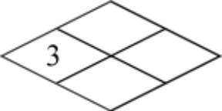
5 | Floor Raised 4 Levels | can move freely into tile from raised 4 | N/A | 
6 | Half Top  (Up Left)  Crouch Under | can move freely into tile if crouched and moving from se to nw or nw to se | N/A | 
7 | Half Top  (Up Right)  Crouch Under | can move freely into tile if crouched and moving from sw to ne or ne to sw | N/A | 
8 | Half Bottom  (Bottom Left)  (Climb Over) | can climb over tile moving from sw to ne or ne to sw | N/A | 
9 | Half Bottom  (Bottom Right)  (Climb Over) | can climb over tile moving from se to nw or nw to se | N/A | 
10 | Gap  (Jump Over) | can move freely into tile, robot falls to its death upon entering tile | N/A | 
11 | Electric Tile | can move freely into tile, robot gets electrocuted to death upon entering tile | Turns off electric field | 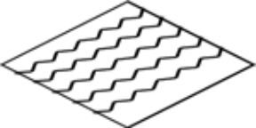
12 | Electric Wall  Top Left | can move freely into tile, if robot attempts to move nw it gets electrocuted to death | Turns off electric field | 
13 | Electric Wall  Top Right | can move freely into tile, if robot attempts to move ne it gets electrocuted to death | Turns off electric field | 
14 | Electric Wall  Bottom Left | can move freely into tile, if robot attempts to move sw it gets electrocuted to death | Turns off electric field | 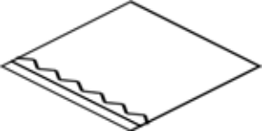
15 | Electric Wall  Bottom Right | can move freely into tile, if robot attempts to move se it gets electrocuted to death | Turns off electric field | 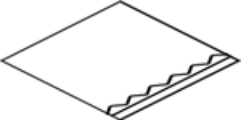
16 | Ice Tile | can move freely into tile, robot automatically moves to the next tile in the direction it was already moving | N/A | 
17 | Water Tile | can move freely into tile, if robot cannot swim, it drowns upon entering | N/A | 
18 | Switch  Top Left | can move freely into tile, if robot is facing the switch wall, activate command will activate the switch | N/A  upon activation, toggles whatever the switch is linked to | 
19 | Switch  Top Right | can move freely into tile, if robot is facing the switch wall, activate command will activate the switch | N/A  upon activation, toggles whatever the switch is linked to | 
20 | Switch  Bottom Left | can move freely into tile, if robot is facing the switch wall, activate command will activate the switch | N/A  upon activation, toggles whatever the switch is linked to | 
21 | Switch  Bottom Right | can move freely into tile, if robot is facing the switch wall, activate command will activate the switch | N/A  upon activation, toggles whatever the switch is linked to | 
22 | Switch  Whole Square | can move freely into tile, activate command will activate the switch | N/A  upon activation, toggles whatever the switch is linked to | 
23 | Re-Program Spot  Top Left | can move freely into tile, if facing the reprogram wall, activate will bring up the reprogramming options | N/A | 
24 | Re-Program Spot  Top Right | can move freely into tile, if facing the reprogram wall, activate will bring up the reprogramming options | N/A | 
25 | Re-Program Spot  Bottom Left | can move freely into tile, if facing the reprogram wall, activate will bring up the reprogramming options | N/A | 
26 | Re-Program Spot  Bottom Right | can move freely into tile, if facing the reprogram wall, activate will bring up the reprogramming options | N/A | 
27 | Re-Program Spot  Whole Square | can move freely into tile, activate will bring up the reprogramming options | N/A | 
28 | Breakable  Top Left | can move freely into tile, if facing the breakable wall, attack will destroy the wall and turn whatever is on the other side of the wall into a standard tile | N/A | 
29 | Breakable  Top Right | can move freely into tile, if facing the breakable wall, attack will destroy the wall and turn whatever is on the other side of the wall into a standard tile | N/A | 
30 | Breakable  Bottom Left | can move freely into tile, if facing the breakable wall, attack will destroy the wall and turn whatever is on the other side of the wall into a standard tile | N/A | 
31 | Breakable  Bottom Right | can move freely into tile, if facing the breakable wall, attack will destroy the wall and turn whatever is on the other side of the wall into a standard tile | N/A | 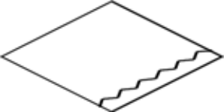
32 | Solid Block | Solid vertical block, this prevents movement through this square | N/A | 
33 | Solid Breakable Block | Solid vertical block, this prevents movement through this square, can be broken from all sides with attack | N/A | 
34 | Start Square | This is the square that the player begins the level in | N/A | 
35 | End Square | This is the target destination | N/A | 
36 | Door  Top Left | can move freely into tile, door can be opened if player is facing the door and activate is used | door is opened when true, closed when false | 
37 | Door  Top Right | can move freely into tile, door can be opened if player is facing the door and activate is used | door is opened when true, closed when false | 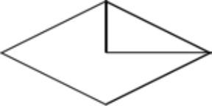
38 | Door  Bottom Left | can move freely into tile, door can be opened if player is facing the door and activate is used | door is opened when true, closed when false | 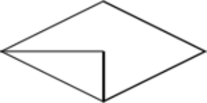
39 | Door  Bottom Right | can move freely into tile, door can be opened if player is facing the door and activate is used | door is opened when true, closed when false | 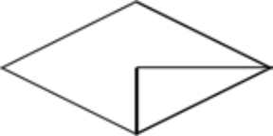

“User Interface Appendix”

“Networking Appendix”

“Character Rendering and Animation Appendix”

“Story Appendix”

Okay, that’s it. I wanted to spend more time on this and really make it a great roadmap for putting a game design together. Unfortunately it would take a ton of time and that is something that we don’t have enough of in this business. I think you get the idea anyhow. Also, don’t get the impression that I think a design should provide the information in any particular order, this just happened to be the way it fell out of my head when I sat down. Change this template any way you want and if you feel you have improved on it, send it back to me and I can pass it out as an alternative to anyone that asks me in the future.

Good luck and all that!

Chris Taylor

